Design Principles – Modularity
# Source: AI Source: Provided by: [Data Path: Persons Table -> ID Column: 1, Name_En Column: Motasem Essam] -> From: [ChatGPT] on [1/23/2026]
Modularity is the principle of dividing a system into independent, interchangeable modules, where each module encapsulates a specific piece of functionality.
👉 Think of it like building with LEGO blocks: each block is self-contained, but together they form the complete system.

🔑 Key Points
# Source: AI Source: Provided by: [Data Path: Persons Table -> ID Column: 1, Name_En Column: Motasem Essam] -> From: [ChatGPT] on [1/23/2026]
- A module is self-contained and has a clear responsibility
- Modules communicate through well-defined interfaces
- Promotes reusability, maintainability, and testability
- Supports parallel development—different teams can work on different modules

❌ Bad Example
# Source: AI Source: Provided by: [Data Path: Persons Table -> ID Column: 1, Name_En Column: Motasem Essam] -> From: [ChatGPT] on [1/23/2026]
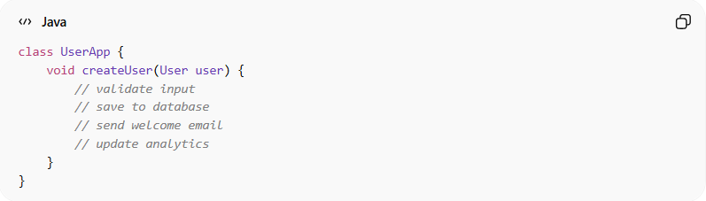
class UserApp {
void createUser(User user) {
// validate input
// save to database
// send welcome email
// update analytics
}
}
Problems:
- Everything in a single class → no clear boundaries
- Hard to maintain or test parts independently
- Adding new functionality breaks existing code

✅ Good Example
# Source: AI Source: Provided by: [Data Path: Persons Table -> ID Column: 1, Name_En Column: Motasem Essam] -> From: [ChatGPT] on [1/23/2026]
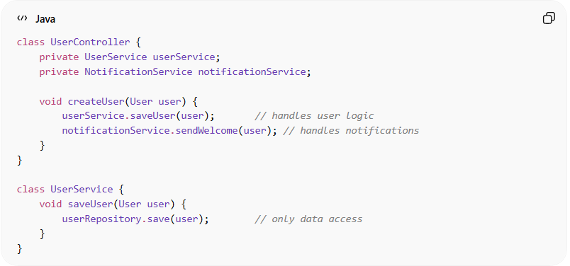
class UserController {
private UserService userService;
private NotificationService notificationService;

void createUser(User user) {
userService.saveUser(user); // handles user logic
notificationService.sendWelcome(user); // handles notifications
}
}

class UserService {
void saveUser(User user) {
userRepository.save(user); // only data access
}
}
Benefits:
- Each module does one logical job
- Modules can be reused in other parts of the system
- Easier to test, maintain, and extend
- Teams can develop independently

⚡ When to Apply
# Source: AI Source: Provided by: [Data Path: Persons Table -> ID Column: 1, Name_En Column: Motasem Essam] -> From: [ChatGPT] on [1/23/2026]
- Always in large applications
- Combine with Separation of Concerns for clear architecture
- Useful for microservices, layered architecture, or modular monoliths

